**P. Sai Teja**

**SER analysis of 2*1 MIMO system using SSK modulation:**

Matlab Code:



**Results:**

**SER analysis of 2*2 MIMO system using OSTB code**

Matlab Code:



Results:

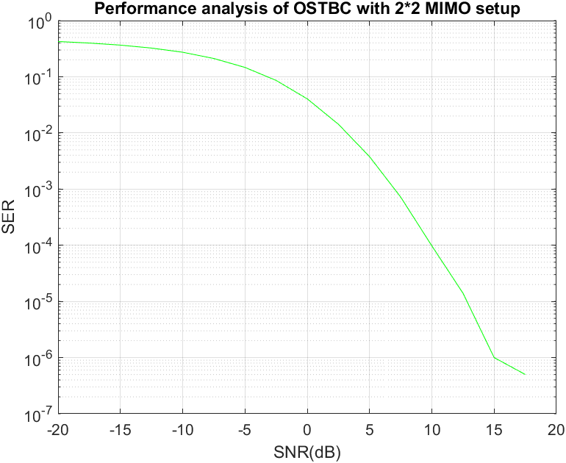

**SER analysis of 4*4 MIMO system using OSTB code**

The OSTBC used for the analysis is shown below.

$$X=\left(\begin{matrix}s_{1} & 0 & s_{2} & -s_{3} \\ 0 & s_{1} & s_{3}^{*} & s_{2}^{*} \\ -s_{2}^{*} & -s_{3} & s_{1}^{*} & 0 \\ s_{3}^{*} & -s_{2} & 0 & s_{1}^{*}\end{matrix}\right)$$

Matlab Code:

Results:

**Observations:**

If we observe the plots of SSK modulation for 2*1 MIMO setup and Alamouti codes for 2*2 and 4*4 MIMO setup we observe that SER goes to zero after a certain SNR.